  - DECLARATION
  - TOWARDS SUSTAINABLE DEVELOPMENT
  - OF SMALL ISLANDS

As stakeholders involved in the management of small islands¹, we recognize the uniqueness and value of islands, in terms of heritage (cultural, natural, historical, or landscape-related; tangible and intangible), and their potential for the development of eco-friendly socio-economic activities.

We have to cope with recurring common issues:
- Important threats from global changes (air and water pollution, intensive use of resources, biological invasions, biodiversity loss, climate changes);
- Seasonal fluctuations in the number of inhabitants and visitors,
- Management of waste, water and energy;
- Existence and maintenance of essential collective services (health, education, transport, etc.);
- Dependence on the outside (raw materials, processed products, etc).

We share a common vision recognizing the need to initiate and continue sustainable development on these territories, that is compliant with the principles of the Rio +20 Declaration, the Aichi Biodiversity Targets2 and Islands Biodiversity Program of Work, and with integrated coastal zone management3 as well as the Regional Seas Conventions4, consisting in:

- Considering the territory as a whole, with land and sea;
- The involvement of all the concerned stakeholders (States, regional and local authorities, economic actors, NGOs, citizens, landowners, experts, users);
- Balanced land management, preservation and promoting heritage;
- The maintenance of healthy ecosystems on the long term, in particular through sustainable use of natural resources, the conservation of biodiversity, and pollution reduction;
- Social and economic development complying with the aforementioned principles, contributing to the well-being of populations and the reduction of inequalities and poverty, by anticipating any negative impact arising from new development projects;
- Taking into account diversity and pluralism of knowledge systems, to better integrate local knowledge and know-hows and scientific knowledge, and to better articulate practices.

We define as common goals:
- To take into consideration while defining our strategies and action plans the founding principles of our common vision;
- To promote the emergence of multi-stakeholders governance models, promoting sustainable land management and involving project beneficiaries in the decision-making processes;
- To mitigate the impacts of global changes threatening these territories, using management tools and technologies, but also encouraging practices and behavior change from the economic stakeholders and users on these territories.

To achieve these goals, we want to implement the following means:
- A network for information exchange to encourage the cooperation and the pooling of our knowledge and skills and favor capacity building
- A pool of experts available to address issues that have been identified out in the field;
- An ecolabel to encourage and showcase the efforts of the territories;
- A platform to share and spread experiences.

Island Committee representative President of the SMILO association

Last name – First name Last name – First name

Signature Signature

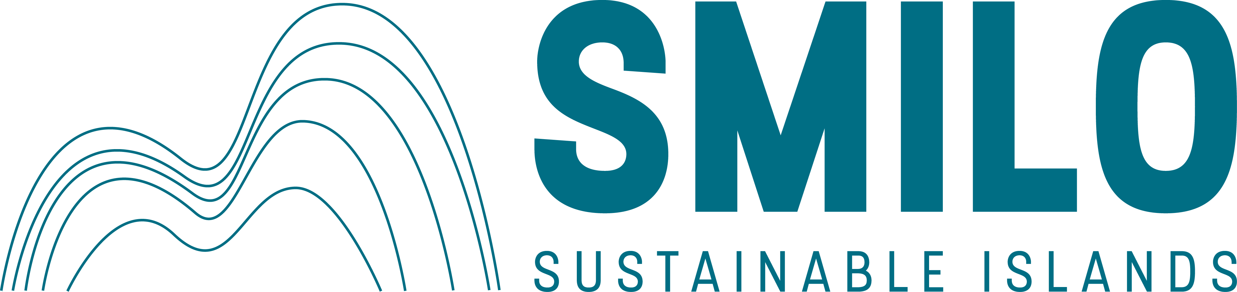

NOTES REGARDING THE REFERENCES MADE IN THE TEXT

1 whose land surface does not exceed 150 km2 ; “real” islands, clearly separated from the main land at low tide, with no bridge to connect them to the main land; Benefiting or not from specific protection status (e.g. Biosphere Reserve, Natural Park, Marine Protected Area, etc.); Inhabited or not

2 Strategic Plan for Biodiversity 2011-2020. Vision: "Living in Harmony with Nature" where "By 2050, biodiversity is valued, conserved, restored and wisely used, maintaining ecosystem services, sustaining a healthy planet and delivering benefits essential for all people."
Including 20 Aichi Biodiversity Targets. https://www.cbd.int/sp/targets/

Strategic Goal A: Address the underlying causes of biodiversity loss by mainstreaming biodiversity across government and society ;
Strategic Goal B: Reduce the direct pressures on biodiversity and promote sustainable use ;
Strategic Goal C: To improve the status of biodiversity by safeguarding ecosystems, species and genetic diversity ;
Strategic Goal D: Enhance the benefits to all from biodiversity and ecosystem services ;
Strategic Goal E: Enhance implementation through participatory planning, knowledge management and capacity building.

3 « Integrated coastal zone management» means “a dynamic process for the sustainable management and use of coastal zones, taking into account at the same time the fragility of coastal ecosystems and landscapes, the diversity of activities and uses, their interactions, the maritime orientation of certain activities and uses and their impact on both the marine and land parts” (According to The Protocol on Integrated Coastal Zone Management to the Convention for the Protection of the Marine Environment and the Coastal Region of the Mediterranean, implemented in 2011).

4 The Regional Seas Conventions and Action Plans will:

- Endeavor to effectively apply an ecosystem approach in the management of the marine and coastal environment in order to protect and restore the health, productivity and resilience of oceans and marine ecosystems, and to maintain their biodiversity, enabling their conservation and sustainable use for present and future generations.
- Contribute to the implementation of the Manila Declaration of the Global Programme of Action for the Protection of the Marine Environment from Land-based Activities, especially in the core partnership areas of wastewater management, nutrients and marine litter. Furthermore, the Regional Seas Conventions and Action Plans will act on provisions related to the development and implementation of protocols addressing land-based pollution sources and activities affecting the marine environment.
- Strengthen capacities at the national level on marine and coastal governance, in order to enable coordination and coherence with systems such as the Large Marine Ecosystem approach, Regional Fisheries Management Organizations and River Basin Organizations, as appropriate.
- Support the provision of tools to decouple economic growth from environmental pressures in the marine and coastal environment by promoting resource efficiency and productivity, including assessing the value of the services provided by these key ecosystems.
- Strengthen coordination and build necessary capacities at the regional and national levels to improve global knowledge and trends on the status of the marine environment, contributing to the World Oceans Assessment (Regular Process).
- Strengthen collaboration mechanisms to address common regional objectives, partnerships and co-ordinated regional implementation of relevant Multilateral Environmental Agreements, global and regional initiatives by United Nations Agencies, such as the International Maritime Organization (IMO), International Atomic Energy Agency (IAEA), Intergovernmental Oceanographic Commission(IOC) of UNESCO, UN Division for Ocean Affairs and the Law of the Sea (DOALOS), United Nations Development Programme, United Nations Industrial Development Organization (UNIDO),Food and Agriculture Organization of the United Nations (FAO), Global Partnership for Oceans of the World Bank, the UN Secretary General’s Oceans Compact, and ICRI.
(http://www.unep.org/regionalseas/about/strategy/default.asp)

